Module-2
Session-1
Ques-1: Write a short paragraph in your own words defining what a ‘program’ is and give one real-life example from any app you use daily (like Instagram, Zomato, or Paytm)?
Ans: Program- A program is a set of instructions that tell a computer or mobile app what to do.
Example:
- Instagram- When we upload photo, the program processes the photo, stores it, and display it on our profile so other users can see it. This happens automatically because of the instructions written in the Instagram program.
- Zomato- When we order food, the program takes our order, send to the restaurant, processes the payment, and helps track the delivery. This shows how a program performs different tasks automatically and makes our daily life easier.
- Paytm- When we send money to someone, the program processes the payment, checks the details, and transfer money to the receiver. This is a real-life example of how a program works in our daily life.
Ques-2: List three popular programming languages you have heard of, and for each, mention whether it is usually compiled, interpreted, or can be both?
Hint: Think of languages like Java, Python, and JavaScript.
Ans:
    - Java- Java is mainly a compiled language.
    - Python- Python is generally considered an interpreted language.
    - JavaScript- JavaScript can be considered both compiled and interpreted.
Ques-3: Draw a flowchart (on paper or using any online tool) for the process of booking a movie ticket on BookMyShow, starting from opening the app to receiving the booking confirmation?
Ans:
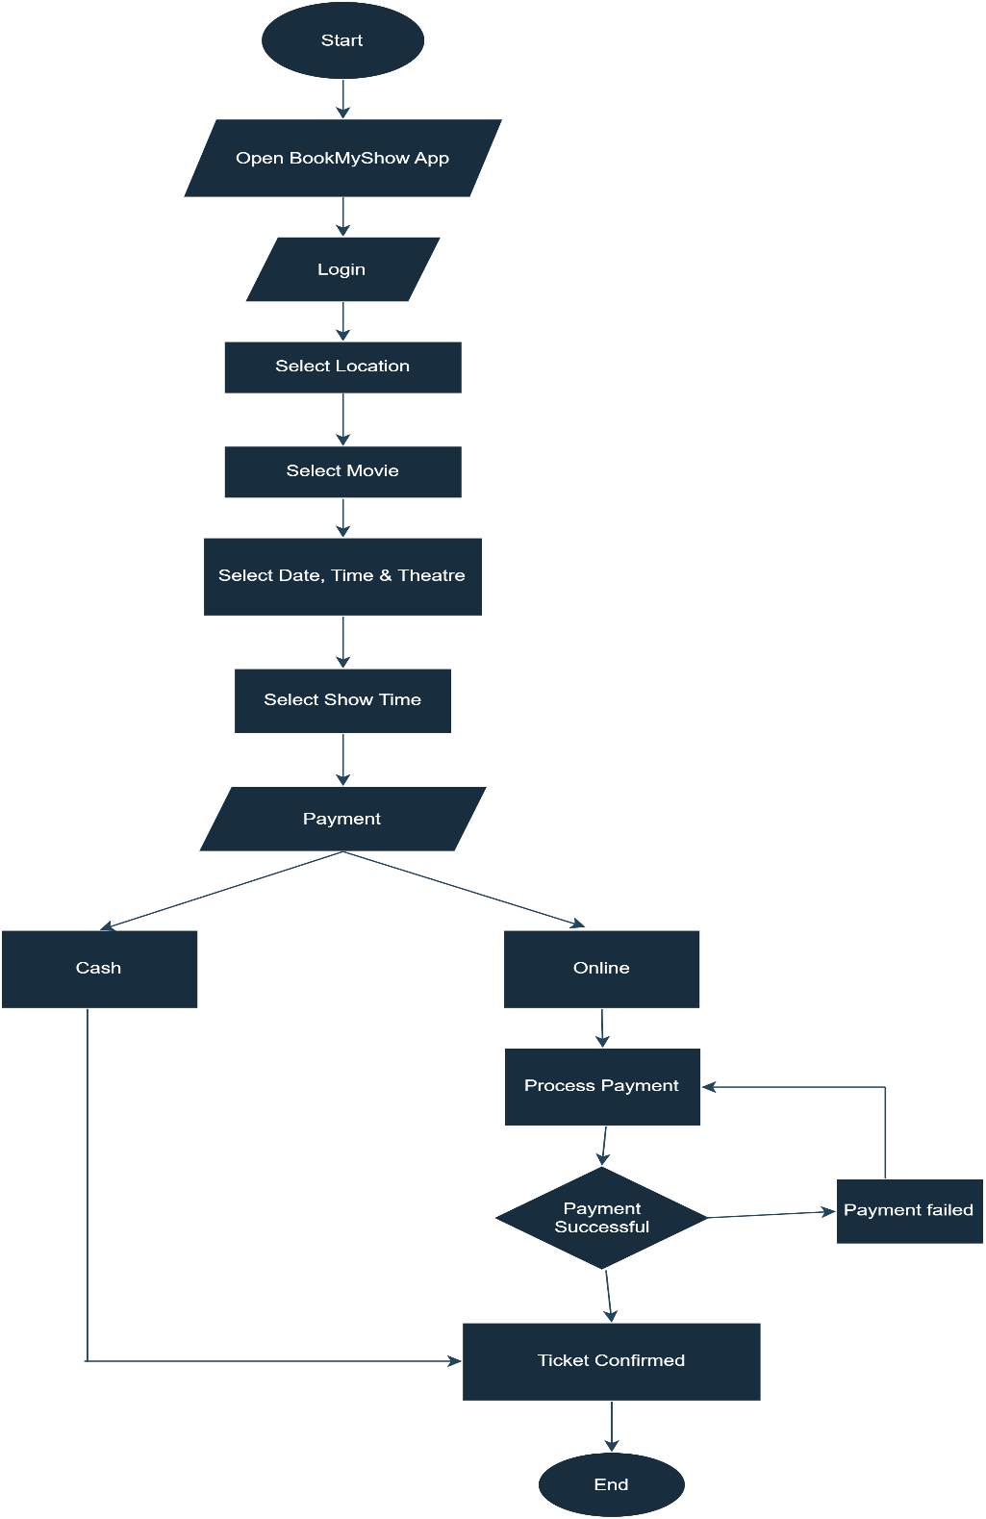

Ques-4: Write down the steps (as an algorithm, using simple numbered instructions) for ordering food on Swiggy — from opening the app to completing payment?
Ans: Algorithm for ordering food on Swiggy-
Step1: Start
Step2: Open Swiggy app.
Step3: Enter mobile number and log in app.
Step4: Enter or confirm delivery address.
Step5: Search for a restaurant or food item.
Step6: Open menu and select food items.
Step7: Add selected items to the cart.
Step8: Open the cart and check the order details.
Step9: Apply a coupon or discount if available.
Step10: Confirm the delivery address and order details.
Step11: Select payment (cash/online).
Step12: Payment successful.
Step13: Receive the order confirmation.
Step14: End.

Payment Success?

